Hospice Volunteer Visitor Training-Fall 2022

About Volunteering with Hospice
The service of a Volunteer is at the heart of what Hospice offers to families who are caring for a loved one who is dying. Volunteer Visitors are understanding listeners, the ones who extend a hand to hold, provide companionship and presence that comforts patients, and often makes it possible for a caregiver to have a few hours of respite.

Hospice of Santa Cruz County (HSCC) has particular needs for specialized volunteers who are:

- Certified Massage Therapists
- Bi-lingual in English & Spanish and/or bi-cultural
- Pet Companion Visitors
- Veterans wanting to serve other veterans

The 18-hour training is especially designed to prepare Volunteers to perform this vital service. HSCC asks that candidates be able to make a volunteering commitment of 2-4 hours per week for at least one year; attend support groups and complete the mandatory annual education requirement that we provide. All training is provided free of charge by HSCC. Volunteers are currently required to have a covid vaccine and booster; TB test (2 step test paid for as part of the training), and background checks which HSCC provides.

Some topics covered in the training include the following:

- Philosophy of Hospice
- Spiritual dimensions of death and dying
- Grief processes and bereavement experiences
- Mindful Awareness practice as a path to service
- Basics of care and safety
- Family systems dynamics
- Self-care and personal/professional boundaries

Hospice of Santa Cruz County honors the choices of individuals and families by providing exemplary end-of-life care and grief support to our community.

Training Schedule-
*All sessions required

Begins: Thursday October 6, 2022 by Zoom

Thursday, October 6 .......... 6–9 PM
Thursday October 13 …..... 6-9 PM
Thursday, October 20 …..... 6-9 PM
Thursday, October 27 …….. 6-9 PM
Thursday, November 3 .….. 6-9 PM
Thursday, November 10 .... 6-9 PM

Application due by: September 26, 2022
*For those who have experienced significant personal loss, it is recommended to wait at least one year before applying.

Information and application

Forbes Ellis, MFT
Director of Volunteer Services Hospice of Santa Cruz County 831-430-3045
Email: fellis@hospicesantacruz.org

Please note: This training will be held by Zoom.

Mailing Address:
Hospice of Santa Cruz County
940 Disc Drive
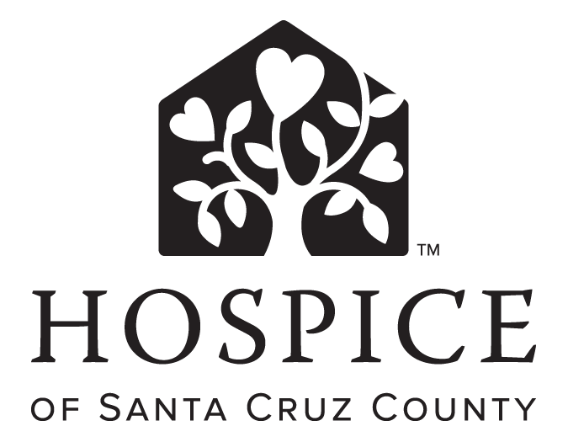Scotts Valley, CA 95066

Apply to Volunteer Today!
fellis@hospicesantacruz.org
Forbes Ellis: 831-430-3045

hospicesantacruz.org
Hospice of Santa Cruz County @HospiceSantaCru

